PYTHON PROGRAMS
Algorithms, Flowcharts, Pseudocode, Test Cases and Output Screenshots
Prepared in simple English based on the provided PyCharm screenshots.
Note: The flowcharts are written as easy arrow steps so they can be copied into a notebook or redrawn using standard flowchart symbols.

1. Shopping Bill Calculator
Aim: To calculate the total cost of three items using their prices and quantities.

Algorithm
- Start the program.
- Set total to 0.
- Repeat for three items: read the price and quantity.
- Check that price and quantity are not negative. If either is negative, display an error and stop.
- Multiply price by quantity and add the result to total.
- Display the total shopping bill to two decimal places.
- Stop.

Flowchart (text form)
Start → Set total = 0 → Enter price and quantity for each of 3 items → Are values non-negative? → No: show error and stop / Yes: add price × quantity → More items? → Yes: repeat input / No: display total → Stop

Pseudocode
START
total ← 0
FOR item ← 1 TO 3
INPUT price, quantity
IF price < 0 OR quantity < 0 THEN
DISPLAY error message
STOP
END IF
total ← total + (price × quantity)
END FOR
DISPLAY total
STOP

Test Cases
Test | Input | Expected result
3 items with valid prices and quantities | Price/quantity values are entered for all three items | Total bill is displayed with two decimal places
A negative price or quantity | Enter a negative value | Error message is displayed and program stops

Output Screenshot
The screenshot shows the total shopping bill as ₹55.00.
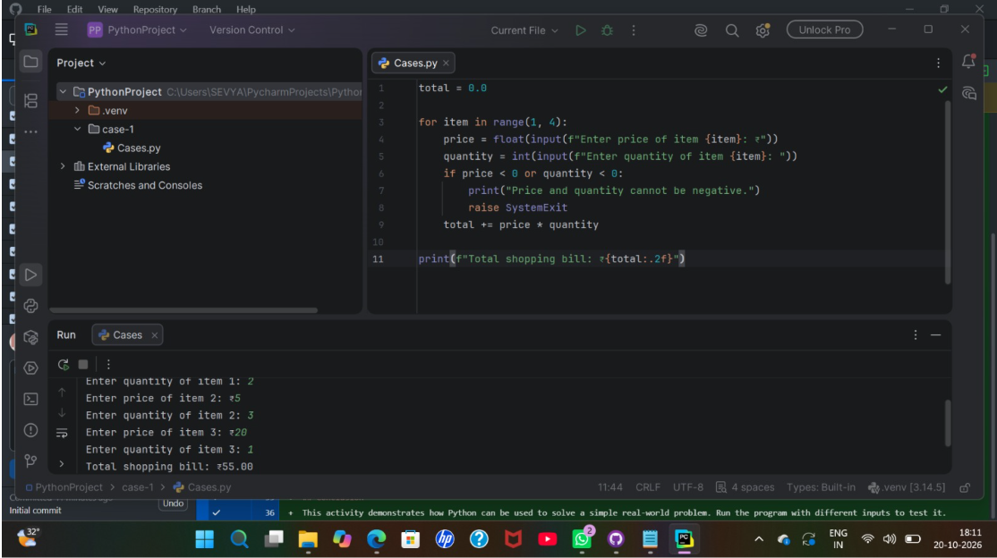

2. Retail Billing System
Aim: To prepare a bill for any number of items and calculate the grand total.

Algorithm
- Start and display the heading RETAIL BILLING.
- Ask how many items are to be entered.
- Set grand_total to 0.
- For each item, read its name, quantity and price per item.
- Calculate subtotal = quantity × price.
- Add the subtotal to grand_total and display the item details.
- After all items are entered, display the grand total.
- Stop.

Flowchart (text form)
Start → Enter number of items → Set grand total = 0 → Enter item name, quantity and price → Calculate subtotal → Add subtotal to grand total → More items? → Yes: repeat / No: display grand total → Stop

Pseudocode
START
DISPLAY "RETAIL BILLING"
INPUT number_of_items
grand_total ← 0
FOR each item from 1 to number_of_items
INPUT name, quantity, price
subtotal ← quantity × price
grand_total ← grand_total + subtotal
DISPLAY name, quantity, price, subtotal
END FOR
DISPLAY grand_total
STOP

Test Cases
Test | Input | Expected result
One book, quantity 1, price ₹50 | Book; 1; ₹50 | Book subtotal = ₹50.00; grand total includes all entered items
Two or more items | Enter names, quantities and prices | Each subtotal and final grand total are displayed

Output Screenshot
The visible output includes Book: 1 × ₹50.00 = ₹50.00 and Grand Total: ₹70.00.
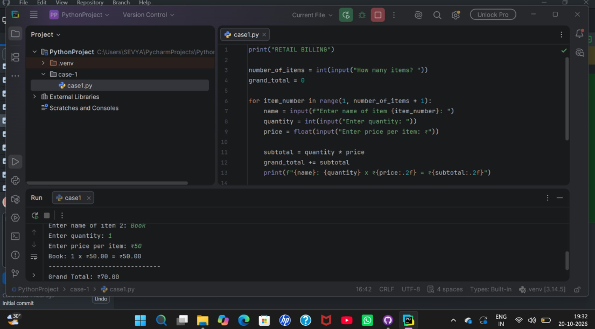

3. Exam Result Calculator
Aim: To calculate average marks, assign a grade and decide whether the student passes.

Algorithm
- Start and ask for the number of subjects.
- Set total marks to 0 and assume the student passes.
- For every subject, read marks out of 100.
- If marks are below 0 or above 100, display an error and stop.
- Add the marks to total. If any mark is below 35, set the pass flag to false.
- Calculate average = total marks ÷ number of subjects.
- Assign the grade using the program's grade conditions.
- Display average, grade and pass/fail result.
- Stop.

Flowchart (text form)
Start → Enter number of subjects → Enter each mark → Marks between 0 and 100? → No: show error and stop / Yes: add marks and check pass mark → All subjects entered? → Calculate average and grade → Display result → Stop

Pseudocode
START
INPUT subjects
total ← 0; all_pass ← TRUE
FOR i ← 1 TO subjects
INPUT mark
IF mark < 0 OR mark > 100 THEN
DISPLAY invalid marks message
STOP
END IF
total ← total + mark
IF mark < 35 THEN all_pass ← FALSE
END FOR
average ← total ÷ subjects
ASSIGN grade using grade rules
DISPLAY average, grade, pass/fail
STOP

Test Cases
Test | Input | Expected result
Marks 90, 85, 95 | Three valid marks | Average = 90.00, Grade A, Result Pass
A mark below 35 | For example, 90, 30, 95 | Result should be Fail because one subject is below 35
Invalid mark | Enter 105 | Invalid-marks message appears and program stops

Output Screenshot
The screenshot shows average 90.00, Grade A and Result: Pass.
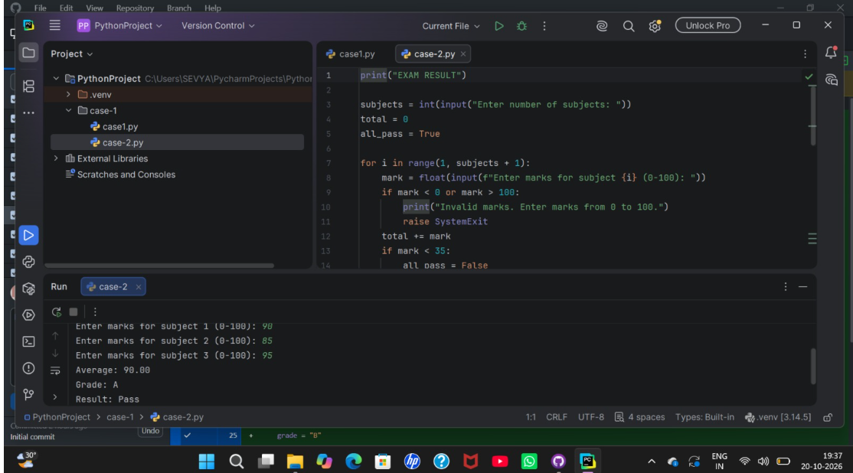

4. Attendance Recovery Calculator
Aim: To find how many extra classes a student must attend to reach a target attendance percentage.

Algorithm
- Start and input classes attended, total classes and target percentage.
- Check that total classes is positive, attended classes are not negative or greater than total, and target is between 0 and 100.
- Calculate current attendance percentage = attended ÷ total × 100.
- Set extra classes to 0.
- While the current percentage is below the target, increase attended classes and total classes by one and increase extra classes by one.
- Display current attendance, extra classes needed and attendance after recovery.
- Stop.

Flowchart (text form)
Start → Input attended classes, total classes and target % → Are values valid? → No: show error / Yes: calculate current % → Is current % below target? → Yes: add one attended class and one total class; count extra class; repeat → No: display result → Stop

Pseudocode
START
INPUT attended, total, target
IF total <= 0 OR attended < 0 OR attended > total OR target < 0 OR target > 100 THEN
DISPLAY invalid values message
STOP
END IF
current ← attended ÷ total × 100
extra ← 0
WHILE current < target
attended ← attended + 1
total ← total + 1
extra ← extra + 1
current ← attended ÷ total × 100
END WHILE
DISPLAY original/current attendance, extra, final percentage
STOP

Test Cases
Test | Input | Expected result
18 attended out of 24; target 75% | 18, 24, 75 | Current attendance = 75%; extra classes needed = 0
Attendance below target | Enter values where current percentage is below target | Program counts extra classes until target is reached
Invalid totals | Total classes = 0 or attended > total | Invalid-values message appears

Output Screenshot
The screenshot shows current attendance 18/24, 0 extra classes and 75.00% after recovery.
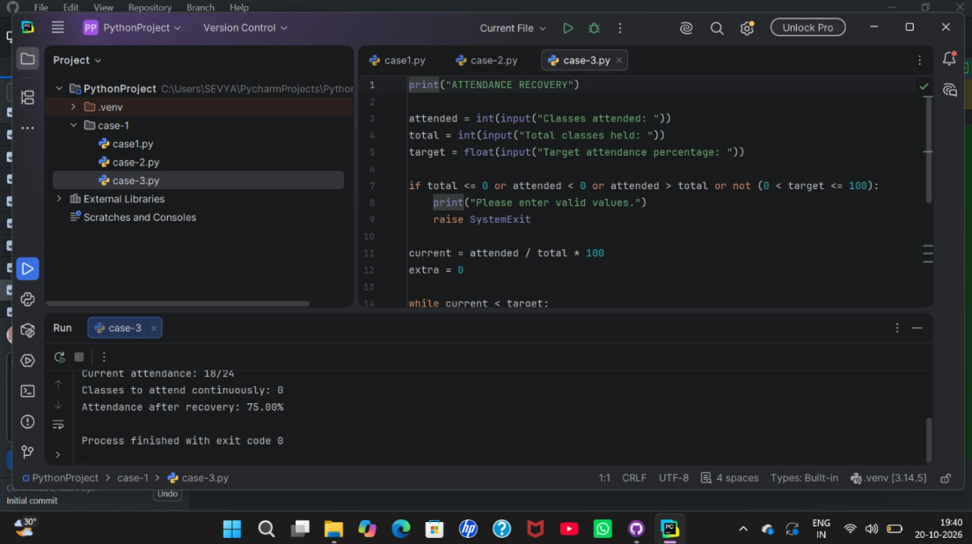

5. ATM Transaction Menu
Aim: To simulate basic ATM operations such as checking balance, depositing money and withdrawing money.

Algorithm
- Start with a balance of ₹5000.
- Display the ATM menu: check balance, deposit, withdraw or exit.
- Read the user's choice.
- If choice is 1, display the current balance.
- If choice is 2, read the deposit amount; add it if it is positive.
- If choice is 3, read the withdrawal amount; withdraw only when the amount is valid and enough balance is available.
- If choice is 4, exit the program.
- For an invalid choice, display a message and show the menu again.

Flowchart (text form)
Start → Set balance = ₹5000 → Display menu → Read choice → Balance / Deposit / Withdraw / Exit → Update or display balance as needed → Exit chosen? → No: return to menu / Yes: Stop

Pseudocode
START
balance ← 5000
REPEAT
DISPLAY menu: 1 Balance, 2 Deposit, 3 Withdraw, 4 Exit
INPUT choice
IF choice = 1 THEN DISPLAY balance
ELSE IF choice = 2 THEN
INPUT amount
IF amount > 0 THEN balance ← balance + amount
ELSE DISPLAY invalid amount
ELSE IF choice = 3 THEN
INPUT amount
IF amount > 0 AND amount <= balance THEN
balance ← balance - amount
ELSE DISPLAY invalid amount or insufficient balance
ELSE IF choice = 4 THEN EXIT LOOP
ELSE DISPLAY invalid choice
UNTIL user exits
STOP

Test Cases
Test | Input | Expected result
Check balance | Choose 1 | Available balance is ₹5000.00 initially
Deposit money | Choose 2 and enter a positive amount | Balance increases by the deposit
Withdraw within balance | Choose 3 and enter an amount not exceeding balance | Balance decreases by the withdrawal
Exit | Choose 4 | Program ends

Output Screenshot
The screenshot shows the initial balance as ₹5000.00.
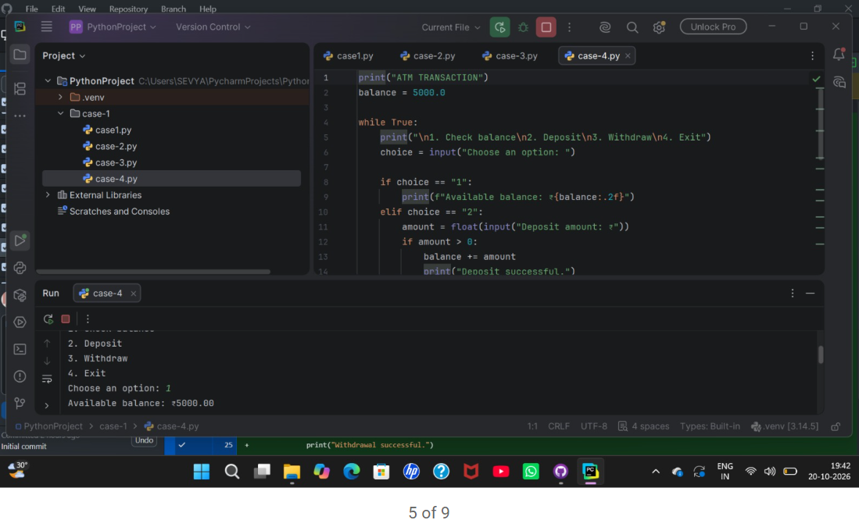

6. Performance Trend Analyzer
Aim: To calculate the average of test marks and identify the performance trend.

Algorithm
- Start and input the number of tests.
- If the number of tests is zero or negative, display a message and stop.
- Create an empty list for marks.
- Read and store the mark for each test.
- Calculate the average using the sum of marks divided by the number of marks.
- Compare the marks to decide whether performance is improving, declining or steady, according to the program's rules.
- Display the average and trend.
- Stop.

Flowchart (text form)
Start → Enter number of tests → Is count positive? → No: show message and stop / Yes: enter marks and store them → Calculate average → Compare marks to identify trend → Display average and trend → Stop

Pseudocode
START
INPUT count
IF count <= 0 THEN DISPLAY message; STOP
marks ← empty list
FOR i ← 1 TO count
INPUT mark
ADD mark TO marks
END FOR
average ← SUM(marks) ÷ LENGTH(marks)
COMPARE marks using trend rules
DISPLAY average and performance trend
STOP

Test Cases
Test | Input | Expected result
Marks 50, 60, 75 | Three tests | Average = 61.67; trend = Improving
No tests | Enter 0 | Message asks for at least one test

Output Screenshot
The screenshot shows marks 50, 60 and 75, average 61.67 and trend Improving.
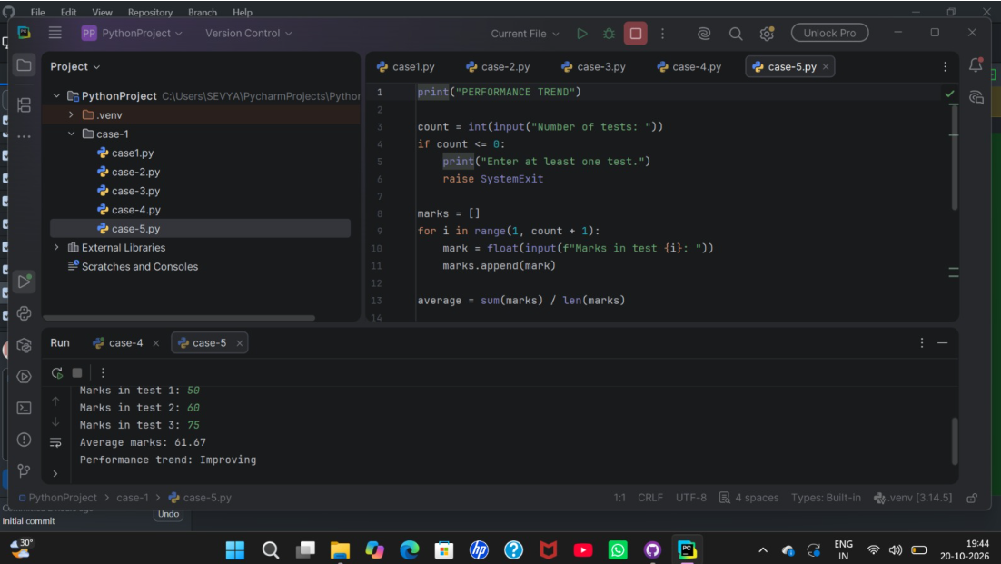

7. Shopping Budget Checker
Aim: To calculate the total cost of items and check whether the total stays within a given budget.

Algorithm
- Start and input the shopping budget.
- Input the number of items.
- Set total cost to 0.
- For each item, read its cost.
- If a cost is negative, display an error and stop.
- Add each cost to the total.
- Display the shopping total.
- If total is less than or equal to budget, display the money left; otherwise display that the budget has been exceeded and show the extra amount.
- Stop.

Flowchart (text form)
Start → Enter budget and number of items → Enter each item cost → Is cost non-negative? → No: show error / Yes: add cost to total → All items entered? → Display total → Is total within budget? → Display money left or amount over budget → Stop

Pseudocode
START
INPUT budget, count
total ← 0
FOR i ← 1 TO count
INPUT cost
IF cost < 0 THEN DISPLAY error; STOP
total ← total + cost
END FOR
DISPLAY total
IF total <= budget THEN
DISPLAY budget - total as money left
ELSE
DISPLAY total - budget as amount over budget
END IF
STOP

Test Cases
Test | Input | Expected result
Budget ₹1000; costs ₹200 and ₹300 | Two items | Total = ₹500.00; money left = ₹500.00
Total above budget | Enter costs whose total exceeds budget | Program reports that the budget is exceeded and shows the extra amount
Negative cost | Enter a cost below zero | Error message appears

Output Screenshot
The screenshot shows a ₹1000 budget, item costs ₹200 and ₹300, total ₹500.00 and ₹500.00 left.
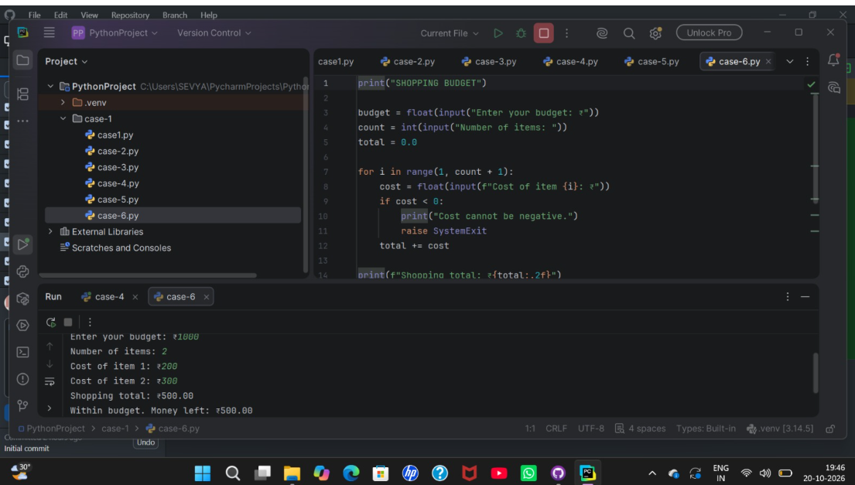

8. Numeric Pattern Generator
Aim: To print a number pattern in which each row displays numbers from 1 up to that row number.

Algorithm
- Start and input the number of rows.
- If rows is zero or negative, display an error and stop.
- Use an outer loop for each row from 1 to the requested number of rows.
- Inside each row, use a loop to print numbers from 1 to the current row number on the same line.
- Move to the next line after each row.
- Stop.

Flowchart (text form)
Start → Enter number of rows → Is rows positive? → No: show error and stop / Yes: begin row loop → Print numbers from 1 to row number → Move to next line → More rows? → Yes: repeat / No: Stop

Pseudocode
START
INPUT rows
IF rows <= 0 THEN DISPLAY error; STOP
FOR row ← 1 TO rows
FOR number ← 1 TO row
DISPLAY number WITHOUT newline
END FOR
DISPLAY newline
END FOR
STOP

Test Cases
Test | Input | Expected result
Rows = 4 | Enter 4 | Pattern rows are: 1; 1 2; 1 2 3; 1 2 3 4
Rows = 0 | Enter 0 | Positive-number message appears

Output Screenshot
The screenshot shows the pattern program running with 4 rows; the lower part of the output is not fully visible.
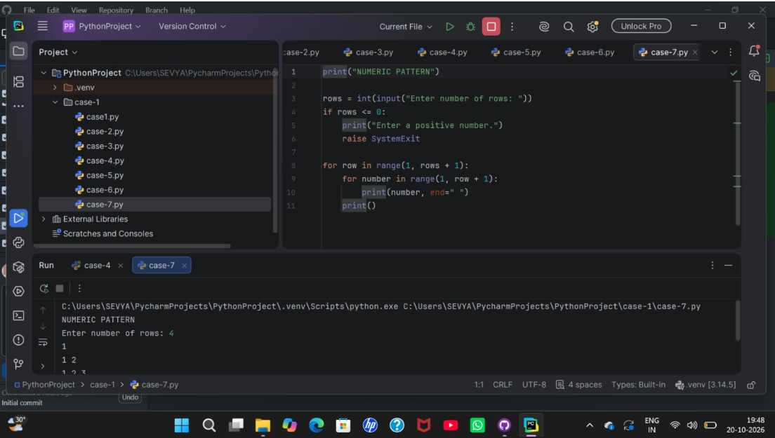

9. Text Compression (Run-Length Encoding)
Aim: To shorten repeated characters by writing each character followed by the number of times it repeats consecutively.

Algorithm
- Start and input a text string.
- If the text is empty, display an empty-input message and stop.
- Set current character to the first character and count to 1.
- Read each remaining character one by one.
- If it matches the current character, increase count.
- Otherwise, add the current character and its count to the compressed string, then set the new character as current and reset count to 1.
- After the loop, add the last character and its count.
- Display the compressed text and stop.

Flowchart (text form)
Start → Enter text → Is text empty? → Yes: show message and stop / No: set current character and count = 1 → Read next character → Same as current? → Yes: increase count / No: append previous character and count; reset current and count → More characters? → Repeat → Append final character and count → Display compressed text → Stop

Pseudocode
START
INPUT text
IF text is empty THEN DISPLAY message; STOP
compressed ← empty string
current ← first character of text
count ← 1
FOR each character in the rest of text
IF character = current THEN
count ← count + 1
ELSE
compressed ← compressed + current + count
current ← character
count ← 1
END IF
END FOR
compressed ← compressed + current + count
DISPLAY compressed
STOP

Test Cases
Test | Input | Expected result
Text = aaabbc | Enter aaabbc | Compressed text = a3b2c1
Text = abcd | Enter abcd | Compressed text = a1b1c1d1
Empty text | Press Enter without typing | Empty-input message appears

Output Screenshot
The screenshot shows input aaabbc and compressed output a3b2c1. The last screenshot is a second view of the same program.
